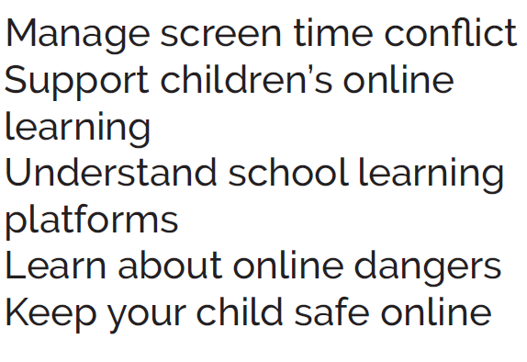

Do you worry about the amount of time your child is spending online, using social media or playing computer games? Would you like to find out about your child’s on-line world and pick up useful tips to help keep them safe?

**St Paul’s Way Trust School**

**Thursday 9 May, 9.30-10.30am**

Sign up here

Free online safety session for parents

delivered by the Parental Engagement Team

**Keeping Children**

**Safe Online**